*Evstigneev Dmitry  
Saint-Petersburg   
Vyazemsky 5-7, room 539  
Russian Federation*[*dimmaxx06202@yandex.ru*](mailto:dimmaxx06202@yandex.ru)

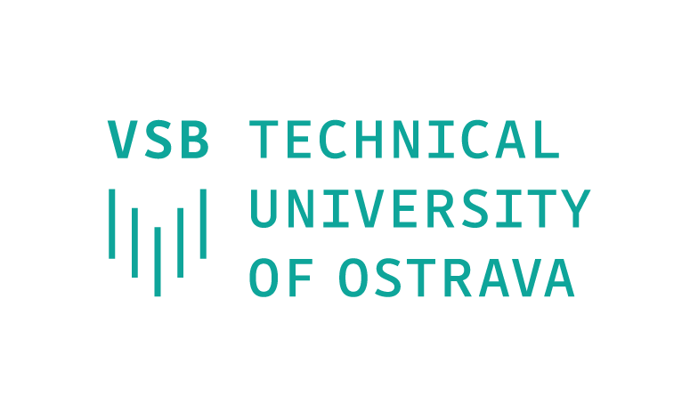

*Technical University of Ostrava, Kamila Pokorná  
17. listopadu 2172/15  
708 00 Ostrava-Poruba  
Czech Republic*[*kamila.pokorna@vsb.cz*](mailto:kamila.pokorna@vsb.cz) *19.09.2021*

To whom it may concern,  
  
I am writing with regard to participation in the exchange program, that ITMO University has with Technical University of Ostrava in Czech Republic.

I am twenty years old, attending third year of studies at the Faculty of Robotics and Control Systems, ITMO University in Russia. My main hobby is the development and design of robots. From an early age I felt like a creative person and realized this in different areas of my life, like drawing, photography etc. But only one lesson in robotics could inspire me so much that I can't even find words to describe it. Over the years at university, I have learned many aspects of my specialization, such as engineering graphics, drafting or mathematical modeling. Although our university has very advanced technical specifications, European standards of education allow much more in technical terms. For this reason, a new engineering opportunity will open up for me if I enter the student exchange program on this semester.

Your program 354-0540/01 (Robotics) fully corresponds with my ambitions, because I have all the skills to start learning, including the required level of English and knowledge of basic engineering and software. I have developed many theoretical and practical projects during my studies, such as laboratory work, essays, programs and coursework about robotics engineering.

My potential in combination with your program will result in the strengthening of my development skills, a new project within your institution and a better partnership with one of the best Russian IT universities.

I will be happy to provide any further information if required.

Thank you for your time and consideration.  
Sincerely,  
Evstigneev Dmitry